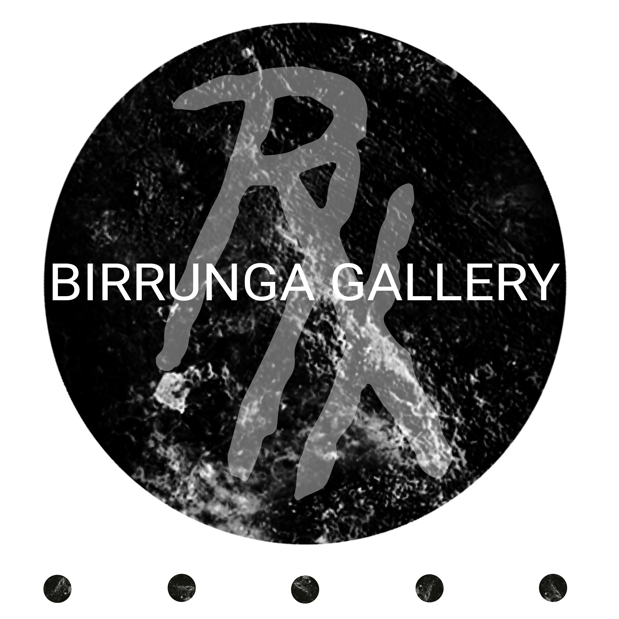
Cultural hub in meanjin (brisbane) cbd
cultural creative development programme
2024 EXPRESSION OF INTEREST FORM:
Aboriginal and or Torres Strait artists are invited to apply for an initial 12-month program with a potential further 2 years.

KEY DATES
CCDP 2024 Intake Expressions of Interest Open | Monday 15th January 2024
CCDP 2024 Intake Expressions of interest Close | Monday 28th April 2024
Shortlisted applicants will be contacted for face-to-face interviews.  Applicants may be invited to subsequent interviews / more in-depth yarns | Monday 13th May 2024
A place will be offered to successful applicants | Monday 17th June 2024

We may offer the applicant a future potential placement with Birrunga Gallery for the ongoing employment after the initial first 12 months of the CCDP.

Eligibility:
To be eligible to participate in the CCDP program you must be an Aboriginal and/or Torres Strait Islander person who is either Brisbane, Gold Coast, or Sunshine Coast based or has cultural connections to the areas referred to as Brisbane, Gold Coast and/or Sunshine Coast.

How to Apply:
Aboriginal and or Torres Strait Islander artists are invited to apply via email. Complete this form and send to bigart@birrunga.com.au
All submissions must be received via email by on 28th April 2024. Anything received after this date will not be considered.

What is our Creative Cultural Development Program?
Our Cultural Creative Development Program (CCDP) matters because it is a unique model of Blak enterprise. This model operates alongside but not in competition with the mainstream examples of enterprise. The program is successful in creating synergies that compliment and add to the existing industry offerings, on our own terms, offering our young people a genuine opportunity to flourish with cultural integrity intact. First steps in delivering this program are broadcasting an Expression of Interest to First Nation’s communities for emerging Indigenous artists to submit a portfolio to apply to be a part of the CCDP.
Successful applicants with be interviewed by a panel of industry experts, where successful applicant(s) will be chosen to be the new inductee(s) to the Creative Cultural Development Program. Our Industry Expert Panel will be led by: Birrunga Wiradyuri, Kane Brunjes and 3 other Industry Experts. Over the course of the year the inductee will be personally mentored by acclaimed international artist Birrunga Wiradyuri alongside lead artist Kane Brunjes. Kane was our inaugural inductee in the Birrunga Gallery CCDP and is now the inaugural Graduate and Lead Artist in the program. The program will present the inductee with opportunities within the corporate world, develop their artistic practice and build their cultural voice. The inductee will create new works along with the artists from the pilot program for an exhibition that will have a theme. This exhibition will then tour to 5 regional locations.
BIRRUNGA GALLERY CCDP
Program founder and convenor Wiradyuri man, Birrunga Wiradyuri, is the founder and principal artist of the multi-award winning Birrunga Gallery situated in the heart of Meanjin (Brisbane) CBD.
Birrunga created the CCDP after meeting Kabi Kabi / Gungarri artist Kane Brunjes in 2019. For Birrunga the program creation and development are a key part of his Cultural responsibility. The CCDP is a unique opportunity for young and emerging Blak artists to engage in a cultural curriculum as a complementary path into becoming a professional cultural practitioner / artist.
‘Kane will very much be hands on from here on in with the development of future applicants to the CCDP. This is exciting news for the program and particularly exciting for those participants who get to work with Kane.’ -Birrunga.
Kane has also shared that the program brings balance to his life in all areas work/personal/mental/physical. His favourite part of the program is the boxing, art, and mentoring conversations with Birrunga. The program has given him the opportunity to get out of his comfort zones and the opportunity to earn a living while being based in Brisbane City as a full-time artist. Kane also really enjoys the collaborative element when working with the pilot cohort on big art projects.
Our CCDP stands as a beacon for promoting Indigenous artistic, cultural, and community development. We've created an inclusive environment where artists, community members, and various stakeholders come together to foster and elevate the local cultural framework.
The CCDP is structured around several core objectives and key components:
Objectives:
1. Cultural Engagement: Deepening the understanding and appreciation of local traditions.
2. Artistic Exploration: Creating avenues for artistic expression and nurturing intergenerational dialogues.
3. Community Empowerment: Engaging the community in pivotal decision-making processes.
4. Online Presence Enhancement: Enhancing the program's digital footprint to connect with a global audience.
5. Long-Term Sustainability: Strategizing to ensure the CCDP remains a cornerstone of cultural development.
Key Components:
1. Workshops and Discussions: Spearheaded by renowned artists, respected local elders, and industry experts.
2. Artist Interactions: Promoting interactions, especially with esteemed artists such as Mentor Birrunga.
3. Art Collection and Curation: Deep diving into the world of art selection and thoughtful presentation.
4. Community Engagement: Ensuring all activities resonate with the community's aspirations.
5. Reflection and Future Planning: Regular intervals of introspection and strategic forward planning.
6. Online Outreach: Boosting digital engagement.
7. Cultural Immersion: Creating meaningful connections with our rich cultural lineage.

APPLICATION
Personal Information:
First Name:
Last Name:
Contact Information:
Email:
Phone:
Address:
Preferred Pronouns:
She/Her
He/Him
They/Them
Other (please specify):

Who is your mob? and/or explain your family's cultural connections?

Where are you based?

Artistic Background:
Brief Artist Biography (150 words max):

Artistic Statement (250 words max):
(Describe your artistic practice, influences, and the themes you explore in your work.)

Have you sold any artworks previously? – If so, please describe background on sold works. If not, please move on to next question.

Are you currently or have you previously worked with any art related businesses or programs? If so, please list. If not, please move to next question.

Program Expectations:
Why do you want to participate in the Cultural Creative Development Program at Birrunga Gallery? (200 words max):

What specific skills or knowledge do you hope to gain from this program? (150 words max):

Artistic Portfolio
Portfolio Submission:
Please provide links to your online portfolio, social media profiles, or upload sample works. (Include at least 5 samples)

Availability and Commitment
Availability: Specify your availability for the program duration.

Commitment: Acknowledge your commitment to actively participate in the program, attend scheduled sessions, and complete assigned tasks.

Additional Information:
Is there any additional information you would like to share or any specific accommodations you require to fully participate in the program?

Declaration:
I, [Your Full Name], declare that the information provided in this form is true and accurate to the best of my knowledge. I understand that incomplete or false information may affect my eligibility for the Cultural Creative Development Program at Birrunga Gallery.

Signature:

(Your Full Name)

Date:
[Date]

